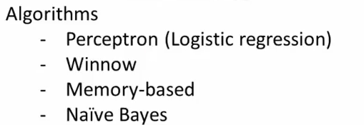
These algos are not used anymore, except the last one

Supervized Learning

There are two types of problems that supervized learning algorithm may be expected to tackle

Regression problem: Example of predicting housing prices based on a finite set of observed prices per surface. Imagine you have a certain set of house prices per surface and you plug them onto a graph. You want to plot a function that would predict prices depending on surface based on the points created by the dataset. What kind of plotting function are you gonna use? Are you gonna plot a straight line through the most points possible or are you gonna favor a quadratic approach and plot a curve that passes through the most points. If you want to predict how high your 200m^2 house will sell, your result will likely vary depending on the function you chose.

This is called linear regression. You get a discrete number of correct answers (collected data set) to a problem and you want to predict continuous values based on these answers, and this is something that deep learning algorithms will deal with very often. The provided data is called training examples

Classification problem: Let's say we have the age and tumor size for several individuals and we want to predict the values of age and size in which tumors are benign and those in which tumors are cancerous, so we want to give them an attribute based on information we have on them, and so the learning algorithm may decide to separate the two groups of tumors, benign and cancerous (shown by drawing a line between a two)

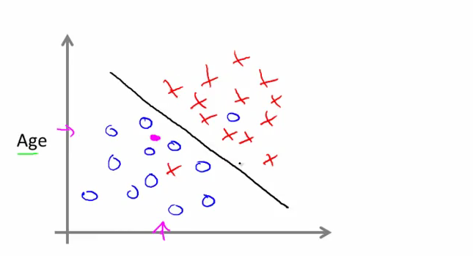
So as we can see, the learning algorithm has to deal not with one feature (surface), but with two, but during this class, we will see an algorithm that can actually work with an infinite number of features.

In supervized learning, we are told what is the correct answer for a finite number of cases and we are trying to predict continuous values or classify new examples based on the empirical classification.

Unsupervized Learning

IN unsupervized learning, much like in classification problems, we are given a set of values on a graph, but they have no distinctive labels, we are not told what each data set is and it is our job to group them into meaningful clusters

Clustering algorithms: Google news clusters thousands of links about news and groups them into meaningful categories. So we don't know the types in advance, and we are asking the algorithm to put them into categories, but we don't know which ones in advance. One example is gene analysis: we study what genes are present in a group of people and we want to classify them, but we are not giving the algorithm the answers in advance.

Second example: Given who people communicate with on social media, can we determine which are the most cohesive groups of friends that all know each other

Such algorithms can analyze audio recordings and separate audio patterns, so if there are two speakers speaking at the same time, it can produce two outputs with each having only one voice.
(It can be done with one line of code)

Also, spam filters.

IN short, unsupervized algorithms are usedd to analyze a set of data and create meaningful categories in which to group the data.

Usually programmers first use matlab or octave to draft and analyze what the algorithm will be, and then only develop it in C++ or Java. So always start in octave

Model and cost function

Let's go back to the housing problem from part I

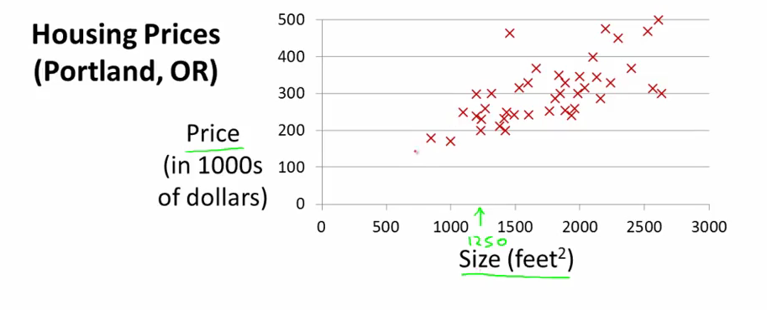
The input variables (x) are called features, the output variables (y) are the target variables, and m is the size of the dataset, or number of training examples.
h(x) is the estimated price for a given x (for example it's the function plotting the straight line in the very first example)

Cost function:

The form in which we make those predictions is a linear function h that looks like this:

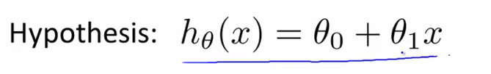
And this is how some of these functions will look like, given different choices for theta 0 and theta 1

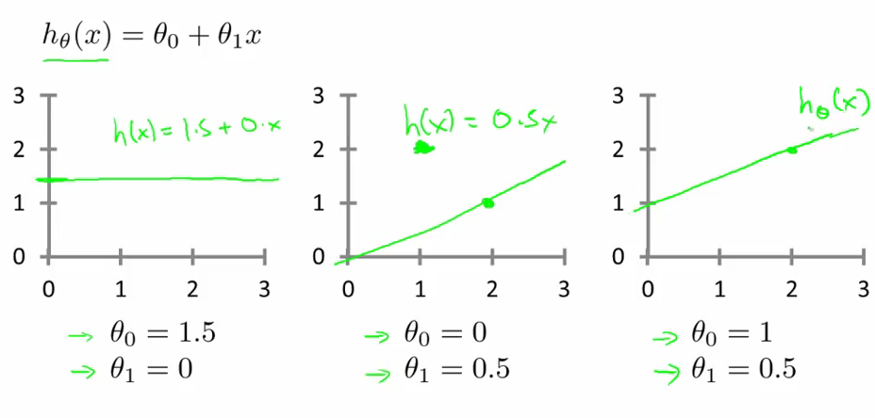
And with that straight line that is plotted by h, we want to be able to cover as many points in the dataset as possible. In other words, we want to minimize (h(x) – y)^2 for all the points in the dataset, so we will actually seek to minimize the sum of these distances:

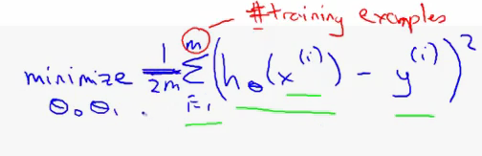
https://chrisjmccormick.wordpress.com/2014/03/04/gradient-descent-derivation/

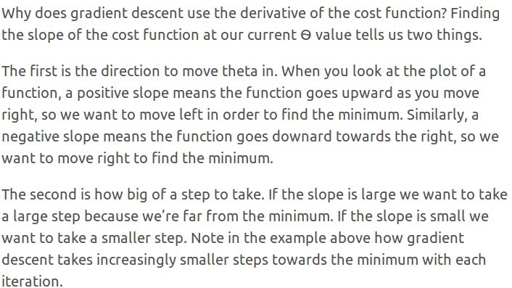

That sum is called a cost function.

Gradient descent minimization: So let's say you want to find the minimum theta of a cost function J(theta) (the blue function above) .The Gradient descent minimization is an iterative algorithm that gets closer and closer to the minimum of the function, basde on information that each iteration provides us about the slope of that function at that point (or the slope of the tangent to that function at that point)

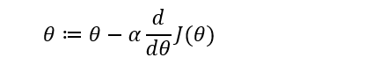

You wanna bring that as close to zero as possible. Alpha is called the learning rate, and is the speed at which you are moving on the J curve. If alpha is too big, you may overshoot the minimum.

In simpler words, the min of a function is where the derivative to that function limit is 0 and the slope for x+ and x- is positive.

We divide the cost function by 2 purely because we can (multiplying by a scalar does not change the location of the minimum) and because it makes life easier down along the way.

By doing this, we hope to find the theta that minimizes the difference in parenthesis between the data set and the plotted function h(x)

Geometric explanation: the sum in J(theta) is simply the sum of the distances between the plotted points and the real points from the data set

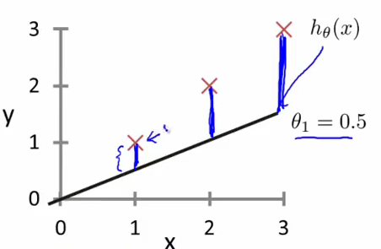

Contour Plots: a contour plot is a graph that you can use to explore the relationship between three variables. Contour plots represent the dimensional relationship in three dimensions: example topographic map

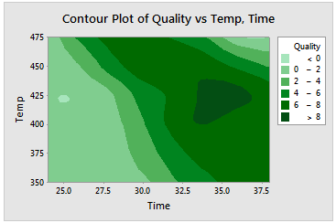

The third variable (the altitude of the terrain) is represented regarding the latitude and longitude with different temperatures of color.

This kind of representation is used when J(theta) is function of two variables (theta0 and theta1)

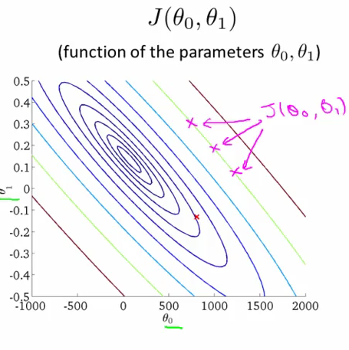

In this contour plot, all the points on a given “circle” give the same value through J, so if we choose them to plot our h function, the cost, or sum of distances between the real and plotted points will be the same for all these couples theta0 and theta1; however of course, this will happen for different functions h every time. By intuition we can see that the minimum for J is near the center of all these ellipses for theta1 = 0.1 and theta0 = 200.

Gradient descent: we learn here how to minimize an arbitrary function using gradient descent. The outline of the algorithm is to start with a theta, and keep changing the theta in the subsequent iterations so that we minimize J. That's why the model is theta – dJ/dtheta * alpha, where alpha is the learning rate.
This method is also called Batch descent because we user all of the training examples in each iteration of the algo
Gradient descent for linear regression: there are no local optimas (other than a global optimum) but there might be local optimas plural for other types of regression.
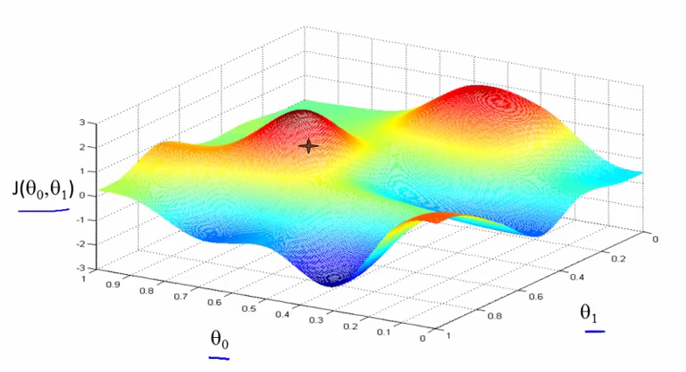
In a more complex example such as this one, what this will allow us to do is determine where we should “go” from our position on that “hill” to reach the bottom of the blue valley as fast as possible (and locate where it is). Each time we take a step, we look around and chose the direction with the steepest decline for our next step. Consecutive tries might lead you to a different local minimum each time, and this is a property of gradient descent.

On a sidenote, the update process has to be simultaneous, such as shown here:
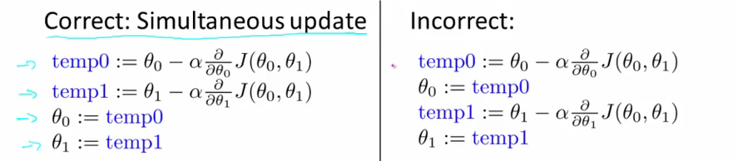
Because of the properties of the derivative at the local minima, if we start our journey already at a minimum, the derivatives will be equal to 0; as a result, theta will remain unchanged if we try to update it, so the model is still correct if we start at a minimum. And because the derivatives' converge to 0 in the minima, they become closer and closer to zero, so the steps we take are automatically smaller and smaller as we approach the minimum so no need to decrease alpha overtime.

Property: A cost function will always be convex.

If there is more than one feature, you have to remember to normalize the vector X because one feature (number of bedrooms) may take values that are on a different scale than the others (sq meters)

